Proxy Design Pattern
Tuesday, May 12, 2020
9:41 AM

Definition:
Provides a surrogate or placeholder for another object to control access to it.
Use an extra level of indirection to support distributed, controlled, or intelligent access.
Add a wrapper and delegation to protect real component from undue complexity.

Remote Proxy : Remote access, responsible for interaction with remote resource
Virtual Proxy : Control access to resource that is expensive to create. The object that we want to interact is expensive to create.
Protection Proxy : Access management, make sure only some users in some conditions are allowed to access to resource.

Key point: The proxy design pattern will save cost. It will create the object that expensive to create only when a method of the object is used.

Client instantiate the proxy, but the proxy will not instantiate the object. And the proxy has the same interfaces as the object. The object will be instantiated until a method a called. -- Create the resource on demand rather immediately.

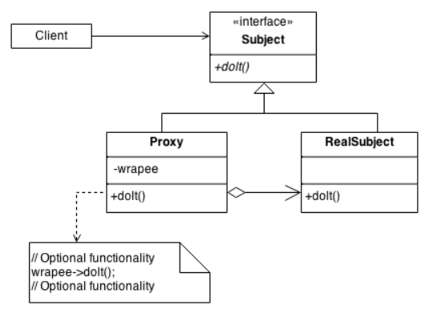

Three points of Proxy Pattern:
Proxy controls the access to the object.
Proxy inherit the same instance as the object.
Proxy doesn't instantiate the object immediately.

